***A Mini Project Synopsis on***

**Car Pooling System**

**S.E. - I.T Engineering**

**Submitted By**

**Mayur Jain 20104024**

**Madhur Dukhande 20104014**

**Anmol Ahirwar 20104131**

**Aryan Amin 20104071**

**Under The Guidance Of**

**Prof. Rucha Kulkarni**



**DEPARTMENT OF INFORMATION TECHNOLOGY**

A.P.SHAH INSTITUTE OF TECHNOLOGY

G.B. Road, Kasarvadavali, Thane (W), Mumbai-400615

UNIVERSITY OF MUMBAI

**Academic year : 2020-21**

**CERTIFICATE**

This to certify that the Mini Project report on **Car Pooling System** has been submitted by **Mayur Jain (20104024), Madhur Dukhande (20104014), Anmol Ahirwar (20104131)** and **Aryan Amin (20104071)** who are the students of A. P .Shah Institute of Technology, Thane as a partial fulfilment of the requirement for the degree in **Information Technology**, during the academic year **2021-2022** in the satisfactory manner as per the curriculum laid down by University of Mumbai.

Ms. Rucha Kulkarni

Guide

Prof. Kiran Deshpande Dr. Uttam D.Kolekar

Head Department of Information Technology Principal

External Examiner(s)

1.

2.

Place:A.P.Shah Institute of Technology, Thane

Date:

**TABLE OF CONTENTS**

1. Introduction.......................................................................................................... 1
   1. Purpose..................................................................................................... 1
   2. Objectives................................................................................................. 1
   3. Scope........................................................................................................ 2
2. Problem Definition………………….................................................................... 3
3. Proposed System………....................................................................................... 4
   1. Features and Functionality…………………………………………………..4
4. Project Outcomes.................................................................................................. 7
5. Software Requirements ........................................................................................ 8
6. Project Design........................................................................................................9
7. Project Scheduling..................................................................................................15
8. Conclusion..............................................................................................................16

References

Acknowledgement

**Chapter 1**

**Introduction:**

Carpooling (also car-sharing, ride-sharing and lift-sharing) is the sharing of car journeys so that more than one person travels in a car, and prevents the need for others to have to drive to a location themselves. By having more people using one vehicle, carpooling reduces each person's travel costs such as: fuel costs, tolls, and the stress of driving. Carpooling is also a more environmentally friendly and sustainable way to travel as sharing journeys reduces air pollution, carbon emissions, traffic congestion on the roads, and the need for parking spaces. Authorities often encourage carpooling, especially during periods of high pollution or high fuel prices.

**1.1 Purpose:**

* The carpooling system merges multiple new people in a car which leads to meet new people in a car, reduces air pollution and noise pollution.
* The carpooling system save economy of every people as they share their rides also share the cost with the other member in car.
* It will stop endless Spending money in travel.

**1.2 objectives:**

* Reducing overall traffic congestion on the roads
* Reducing single occupancy car trips by implementing car pooling system
* Promoting alternative modes of transport.
* Improve parking in areas that are experiencing parking congestion

**1.3 Scope:**

* Registration for users for security.
* Provides pool details to the user.
* Can create his/her own pool.
* Approval/Disapproval totally depends on driver.
* User-Friendly.
* Blind can also operate it.
* Track the location till the pool is made.
* Carpooling head-office track each & every pool, so
* it helpful to take action if someone is in trouble.

**Chapter 2**

**Problem definition**

* There is acute problem of traffic on roads these days and the increasing fuel prices add to the misery of daily users of personal vehicles.
* Also use of vehicles causes pollution which has its adverse affects. Car sharing is a solution but issues like security and trust come into picture.

**Chapter 3**

**3.1 proposed system:**

* Our proposed system overcomes the drawbacks of the existing system. It has advance facilities to make it more user-friendly.
* It provides details of the owner and his/her car to maintain transparency between users of the system
* It will track the location of users those who involve in pool through GPS Navigation system.
* It has SMS Alerts facilities for notification purpose. The High security makes it faithful to use.
* The security aspects gets more enhance by SOS facilities if the user is in trouble. It is available on Smartphone’s so it is more flexible & dynamic to use.

**3.2 Features and Functionalities:**

* Login - Since all the operations that can be done using the application requires both the driver and passenger to be logged in, they can use the login forms of either Google Plus or Facebook. For this matter, the user is prompted to connect the app to his account and then proceed for sign in/up. After the user authorizes the application to access his social media account, the server retrieves his info. If he has never logged to the application before, a new account is created for him.
* Modify profile information - All users can modify their profile information. The profile information contain: name, phone number, email, type/color of car if any. The user can easily edit these information in order to be contacted and recognized
* Rate driver/passenger - Both the driver and passenger can rate each other in other to gain reputation. The importance of the rating is to encourage users to be helpful and nice during the trip so that they gain popularity in the application. It is also a way to ensure users of who can be trusted or not. The ratings represent a relative guarantee for the users to trust each other.
* Create new regular trip - The driver can create a new trip to be displayed when passengers search for trips. The application will prompt the driver or information of the regular trip which consists of destination, origin, meeting point ( which can be pointed in a map), departure time/date , estimated arrival time and traveling preferences (number of free spots, price, size of bags, smoking/non-smoking, pets, stops …). After providing this information, the user publishes it in order to find passengers. Upon the creation of the trip, a user can share the trip he just created in social media to find passengers to drive with.
* Check-in trip - Whenever the driver or passenger arrive to the meeting point at the time agreed upon, he can check-in the meeting point in order to notify the other user and to show his punctuality. The application will use the devices GPS in order to make sure that the users are in the meeting point. When somebody checks a notification is sent to all the carpoolers saying that somebody is in the meeting point.

# Chapter 5

**Software stack:**

**Front End: VS Code**

Visual Studio Code is a code editor in layman’s terms. Visual Studio Code is “a free-editor that helps the programmer write code, helps in debugging and corrects the code using the intellisense method ”. In normal terms, it facilitates users to write the code in an easy manner. Many people say that it is half of an IDE and an editor, but the decision is up to to the coders. Any program/software that we see or use works on the code that runs in the background. Traditionally coding was used to do in the traditional editors or even in the basic editors like notepad! These editors used to provide basic support to the coders.

**Backend: MY SQL**

MySQL is an open-source relational database management system (RDBMS).Its name is a combination of "My", the name of co-founder Michael Wideness’s daughter, and "SQL", the abbreviation for Structured Query Language. A relational database organizes data into one or more data tables in which data types may be related to each other; these relations help structure the data. SQL is a language programmers use to create, modify and extract data from the relational database, as well as control user access to the database. In addition to relational databases and SQL, an RDBMS like MySQL works with an operating system to implement a relational database in a computer's storage system, manages users, allows for network access and facilitates testing database integrity and creation of backups.

**Implementation:**

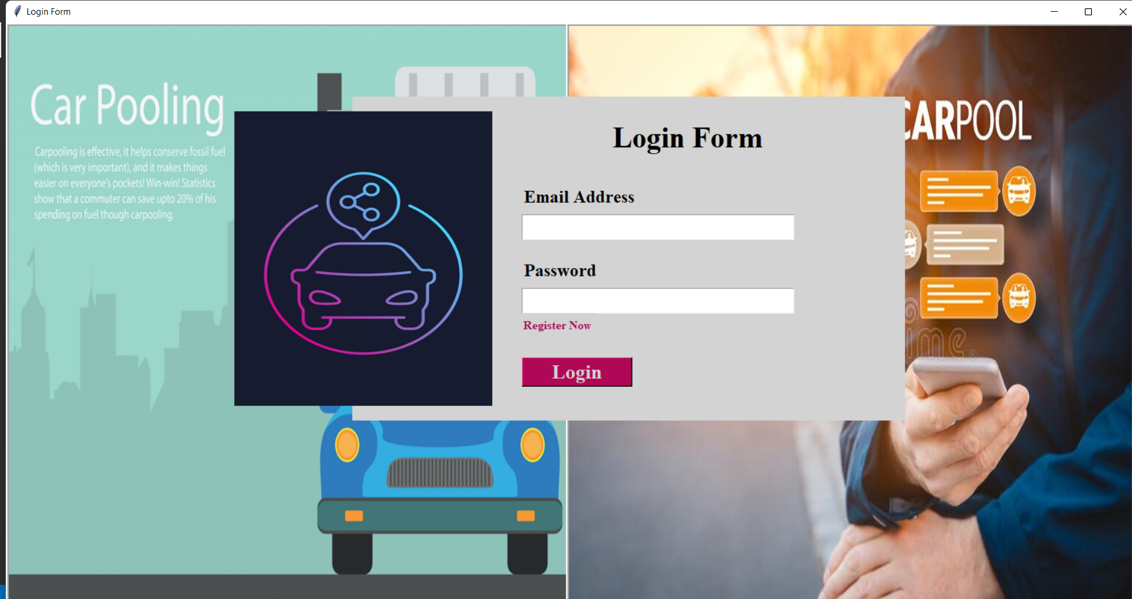

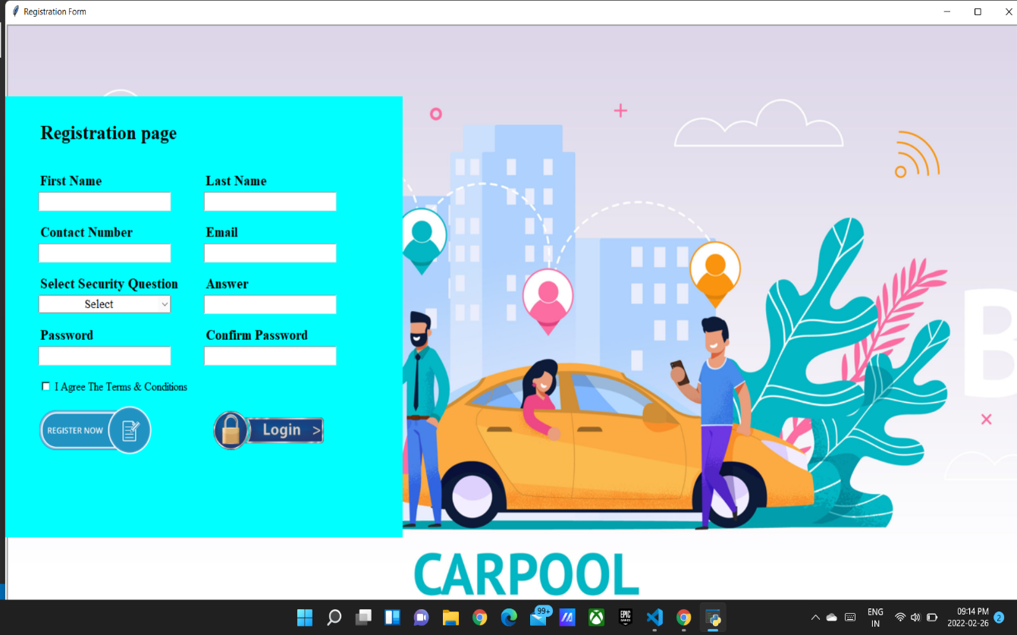

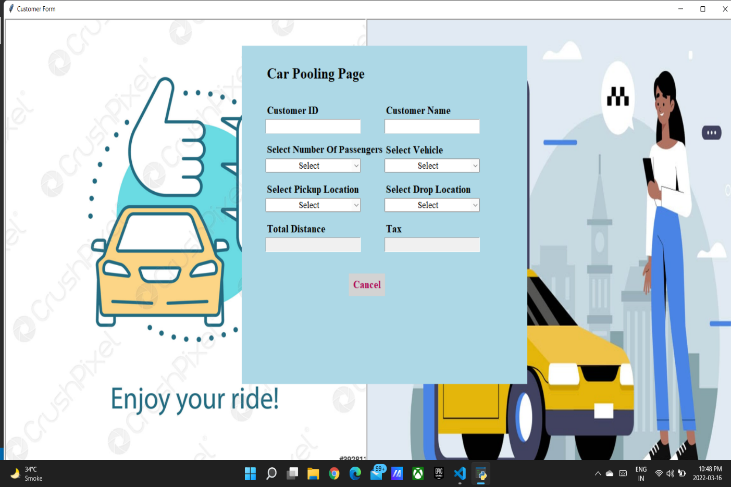

**Chapter 8**

**Project scheduling**

**Project scheduling template**

|  |  |  |  |
| --- | --- | --- | --- |
| **1** | Anmol Ahirwar | 1st week of january | Implementing 1st module/ functionality (Designing the main page/admin will login with security verification and will enter to the main menu) |
| **2** | Mayur Jain | 2nd week of january | Testing 1st module  Testing GUI with database 1.Signup 2.Login  3.Forgot password 4.Mainframe |
| **3** | Madhur Dukhande | 3rd week of january | Implementing 2nd module/ functionality (designing next page/ functionality: Here information of Cars , available rides will be shown) |
| **4** | Aryan Amin | By the end of march month | Implementing 3rd module/ functionality (Transfer page/ functionality: On this page admin can view the list of people who needs cars or have kept cars for rent.) |

**Conclusion:**

**At the end it is concluded that we have made effort on following points** …

* This carpooling application is an application that complies to the enterprise class application principles.
* It is designed to be performing, scalable, extensible, and highly available.
* It also ensures the privacy of the users’ data and secures its access. Given that it may be improved in many ways, the application is also easily maintainable.
* The constraint that should have been considered is that developing a server and an application demand a lot of work. This should be considered in the time allowed for each one of these activities.
* Due to this lack of time, many things can be improved in the present application. This includes a better user interface with more attractive styles.
* Also, adding more support for authentication systems can be an improvement.

**References**

1**.**R.Hasan, A.H. Bhatti, M.S. Hayat, H.M. Gebreyohannes, S.I. Ali, A.J. Sayed, 2016 3rd MEC International Conference on Big Data and Smart City (ICBDSC), 1--6, (2016).

2. Farin, N. Jahan and Rimon, M. N. Ahsan Ali and Momen, Sifat and Uddin, M. Shorif and Mansoor, Nafees, 2016 International Workshop on Computational Intelligence (IWCI), 204--208, (2016)

3. Hsieh, F. Shiung, 2017 IEEE 31st International Conference on Advanced Information Networking and Applications (AINA), 972--978,(2017)

4. Hsieh, F. Shiung and Zhan, Fu-Min, 2018 IEEE 42nd Annual Computer Software and Applications Conference (COMPSAC), 1, 577--582,(2018)

5. Campana, M. Giovanni and Delmastro, Franca and Bruno, Raffaele, 2016 IEEE 19th International Conference on Intelligent Transportation Systems (ITSC), 1856--1862,(2016)

6. Carrese, Stefano and Cipriani, Ernesto and Giacchetti, Tommaso and Sottile, Eleonora and Zamberlan, Leonardo, 2019 6th International Conference on Models and Technologies for Intelligent Transportation Systems (MT-ITS), 1--6,(2019)

7. Zhang, Sijia and Jia, Shunping and Ma, Cunrui and Wang, Yuqiong, 2018 IEEE 3rd International Conference on Cloud Computing and Big Data Analysis (ICCCBDA, 280--284, (2018)

## ACKNOWLEDGEMENT

This project would not have come to fruition without the invaluable help of our guide **Ms**. **Rucha Kulkarni** . Expressing gratitude towards our HOD, **Prof. Kiran Deshpande**, and the Department of Information Technology for providing us with the opportunity as well as the support required to pursue this project. We would also like to thank our teacher **Ms. Anagha Aher** who gave us her valuable suggestions and ideas when we were in need of them. We would also like to thank our peers for their helpful suggestions.